HTML
1.1 Introduction
The language used to develop web pages is called HYPERTEXT MARKUP LANGUAGE. or HTML is a system of codes that you use to create active documents. That is documents with which you and others can interact.
HTML is the language interpreted by the browser. Web pages are also called HTML documents. HTML is a set of special codes that can be embedded(गुंतलेले)in text to add formatting and linking information called tags.
1.2 HTML Features
(i) HTML is a document layout and hyperlink specification language.
(ii) HTML lets you jump from topic to topic rather than finding and reading information linearly.
(iii) HTML defines the syntax and placement of special, embedded directions that aren't displayed by the browser, but it tells the browser how to display the contents of the document, including text, images and other support media.
(iv) HTML tells you how to make a document interactive through special hypertext links.
1.3 HTML Tags
The tags are instructions that are written directly into the text of the document. An HTML tag is a signal to a browser that it should do something other than just throw text up on the screen. By convention all HTML tags begin with an open angle bracket (<) and end with a close angle bracket (>).
HTML tags can be of two types :
1.3.1 Paired tags : A tag is said to be a paired tag if it, along with a companion tag, flanks the text. For example, the <B>tag is a paired tag with its companion tag </B>. It causes the text between them to bebold format. The effect of other paired tags is applied only to the text they contain.In paired tags, the first tag <B> is called the opening tag and the second tag </B>. is called the closing tag.
1.3.2 Singular tags : The second type of tag is the singular or standalone tag. A stand-alone tag does not have a companion tag. For example, <BR> tag will insert a line break.
1.4 The Structure of an HTML Program
In every HTML program, a program has a rigid structure. The entire web page is enclosed within <HTML></HTML> tags. Within these tags, two distinct sections are created using the <HEAD></HEAD> tags and the <BODY></BODY> tags.
1.4.1 Document Head : Information placed in this section is essential to the inner working of document and has nothing to do with the content of the document, except <TITLE></TITLE> tag. All information placed within the <HEAD></HEAD> tag is not displayed in the browser.
1.4.2 Document Body : The tags used to indicate the start and end of the main body of textual information are :<BODY></BODY>
How to create and view HTML document ?
Step 1 Open Notepad from Accessories
Step 2 Write html coding
Step 3 Save this file with proper name and extension with .htm or .html
Step 4 To view this file in the browser, open Internet Explorer or Netscape Navigator browser
Step 5 Give full path of html document in the address bar of browser. You will get the desired Web page.
The structure of an HTML program is as follows -
<HTML>
<HEAD>
<TITLE>
Title to be displayed at the title bar of the browser is written here.
</TITLE>
</HEAD>
<BODY>
Different tags can be used here to format the page.
</BODY>
</HTML>

1.5 Commonly used HTML tags
Following are the commonly used HTML tags :
1.5.1 The <HTML>Tag : The <HTML> and </HTML> tags limits the beginning and end of an HTML document. The end tag </HTML> may be omitted. This tag contains head tag, body tag, frames.
1.5.2 The <HEAD> Tag: The HTML document header describes the various properties of the document, including its title, position within the web browser and relationship with other documents. The <HEAD> tag defines the document header. This tag ends with the </HEAD> and contains head contents. The <HEAD> tag may contain a number of other tags that define and manage the document's contents. This tag is placed just after the <HTML> tag and before the <BODY> or <FRAMESET> tag.
1.5.3 The <TITLE>Tag : The <TITLE> tag defines the document title.It ends with the </TITLE> tag. It contains the plain text. The words placed inside its start and end tags define the title for the document.
1.5.4 The <BODY> Tag : The <BODY> tag defines the document body.Anything inside the <BODY> and </BODY> tag, is called body content The <BODY> tag has a number of attributes that control the colour and background of the document.Some of the attributes of the <BODY> tag are as follows :
(i) ALINK: It defines a colour for active link text.
(ii) LINK: It determines the colour of all hyperlinkwhich are not yet followed by the user.
(iii) VLINK: It sets the colour of all links the user had followed at one time or another.
(iv) BGCOLOR: Changes the default background colour tospecified colour name or its equivalent hexadecimal number.
(v) BACKGROUND : Specifies the path of an image file that will be used as the background of the document.
(vi) TEXT: Changes the body text colour from its default value to the specified colour.
(vii) TITLE: Displays the title associated with the backgroundimage when the mouse pauses over that element.

1.5.5 Heading Tags : The heading tags are used to define the levels of the headers. The six heading tags, written as <H1>, <H2>, <H3><H4>, <H5>and <H6>.<H1> displays text in largest size.<H2> displays text in smallet size than text size of <H1>,<H2> displays text in larger size than text size of <H3>.<H3> displays text in large size than text size of <H4>.<H4> displays text in large size than text size of <H5>.<H5> displays text in larger
size than text size of <H6>.The appropriate heading end tags, </H1>, </H2>, <H3>, </H4>, </H5> and </H6>, respectively, must be included in the document. The heading tags provide the alignment settings as left, center, right and justify with the align attribute.
1.5.6 The <COMMENT> Tag: The comments can be placed within the <COMMENT>
tag. Everything between the <COMMENT> and </COMMENT> tag is ignored by the Internet Explorer, but all other browsers will display the comment to the user. Therefore, instead of <COMMENT>, the <!- - and - -> sequences are used to as the comments. Browsers ignore the text between these comment character sequences.
Example 1.1: Following example displays a simple HTML document with the tags - HTML, HEAD, TITLE & BODY,
<html>
<head>
<title>INFORMATION TECHNOLOGY </title>
</head>
<body text="navy" link=”blue" alink="red" vlink="blue">
The language used to develop web pages is called HyperText Markup Language (HTML).
<!-- body tag defines the document body —!>
</body>
</html>

Example 1.2 : Following example displays heading tags used to define the levels of the headers.
<html>
<head>
<title>INFORMATION TECHNOLOGY </title>
</head>
<h1>Wel Come to the world of INTERNET </h1>
<h2>Wel Come to the world of INTERNET </h2>
<h3>Wel Come to the world of INTERNET </h3>
<h4>Wel Come to the world of INTERNET </h4>
</body>
</html>
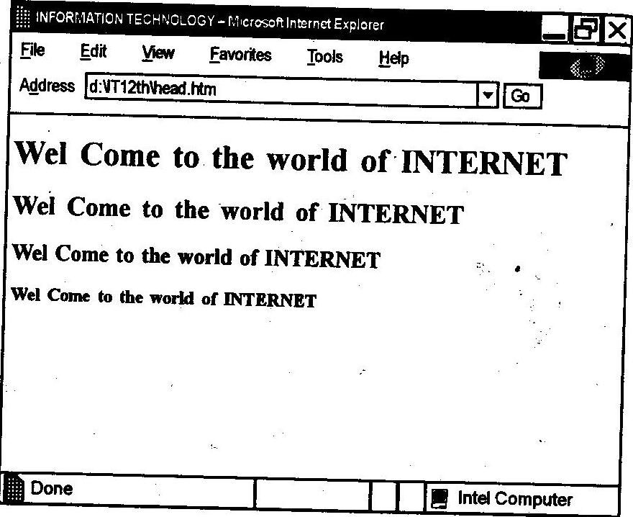

1.2 : Heading tags used to define the levels of the headers

1.5.7 The <P> Tag: The <P> tag defines a paragraph of text. Each paragraph starts with <P> and ends with the corresponding </P> tag. The end tag </P> is usually omitted. The <P> tag contains the text The <p> tag provides four kinds of content justification: Left, center, right and justify and can be assigned with the attribute align.
1.5.8 The <BR> Tag : The <BR> tag inserts a line break into a text flow.When the text needs to start from a new line and not continue on the same line, the <BR> tag should be used. It has no ending tag.
1.5.9 The <HR> Tag: The <HR> tag draws lines and horizontal rules.This tag draws a horizontal line across the whole page, if not specified.The attributes to the <HR> tag are :
(i) ALIGN : Aligns the line on the browser screen to left,center or right. By default, the line is aligned to the center of the screen.
(ii) SIZE: Changes the size of rule.
(iii)WIDTH:Sets the width of rule.
1.5.10 Physical style tags
Formatting Tags :
The <B> Tag : The <B> tag boldfaces a character or segment of text that is enclosed between tag <B> and its corresponding </B> end tag.
The <I> Tag : The <I> tag and its </I> end tag render the enclosed text in an italic or oblique typeface.
The<U>Tag :The <U> tag underlines the text contained between it and its corresponding </U> tag.
The <S> Tag : The <S> tag puts a line through text that appears inside the <S> tag and its </S> end tag.
1.5.11 The <BIG> and <SMALL> Tags : (i) The <BIG> tag renders between it and its </BIG> ending tag one font size larger than the text.
The <SMALL> tag renders the text between it and its ending tag one font size smaller than the surrounding text.
1.5.12 The <SUB> and <SUP> Tags: (i) <SUB> The text contained the <SUB> tag and its </SUB> end tag gets displayed half a characters height lower, but in the same font and size as the current text.That is, this tag is used to subscript the text.
(ii) <SUP> The <SUP> tag and its </SUP> end tag superscripts the text, it gets displayed half a character's height higher, but in the font and size as the current text flow.
1.5.13 The <PRE> Tag : The <PRE> tag and its required end tag </PRE> define a segment inside which the browser renders a-block of text any formatting. This tag displays the text in exactly same format as character and line spacing format defined in source HTML document.The attributes provided by <PRE> tag are :
(i) ALIGN : Allows to set alignments as left, center, right or justify.
(h) WIDTH : Determines the number of characters to fit on a single line within the <PRE> block..

